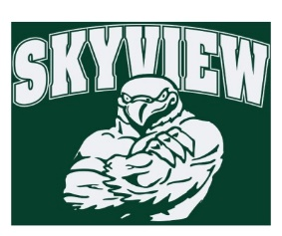
5.12.19 Edition
HAWK HAPPENINGS

MCC Officer Nominations are now open
Nominations have been extended for MCC Officers for the 2019-2020 school year.
Please complete the nomination form: https://goo.gl/forms/N7kz3CQJFCfWIqgv2
Nominations should be emailed to Marie Kramer at marie.kramer@comcast.net

MHS Multicultural Club International Festival May 18
Multicultural Club at Methacton High School is once again hosting the annual Methacton School District International Festival! Join us in celebrating the diverse backgrounds that students and their families come from through ethnic food, music, dance, and much more! Last year’s International Festival was a great success with over 20 cultural exhibits and performances representing countries and international organizations around the world.

We are currently looking for presenters for this year’s MSD International Festival, which will be held on Saturday, May 18th from 10 AM to 2 PM at Methacton High School. Table-top exhibits can represent a specific country or an international organization such as Girl Scouts of America. Performances such as dance, martial arts, and music are also welcomed!

If interested, please fill out the attached form with information about your exhibit/performance.
(https://goo.gl/forms/7w0JeNFaUecpKcBz2).
Please email mhs2multiculturalclub@gmail.com for questions or inquiries.

Home & School Meeting Minutes
Can’t make the meetings? Stay informed through Konstella! Meeting minutes are posted on Konstella each month.

Library and Lunch Volunteer sign-ups are now on Konstella!
Box Tops for Education and Giant A+ Rewards
- Boxtops - Please continue to clip and send into school. The drop off box is in the school's lobby. The class with the most submissions earns a reward!
- Register for Giant A+ School Rewards at www.giantfoodstores.com/aplus . Our School ID is #25955.
Coming Soon:
- 6/7/19 – Fun Day (rain or shine!)
Your comments, feedback, and suggestions are welcome. We enjoy working with our families to create the best experiences for all the students at Skyview. Someone is always available to assist you. Contact us at: skyviewhomeandschool@gmail.com. You can also stay informed by visiting the Skyview Home & School Webpage - https://www.methacton.org/Page/12809

